**IT253 LAB ASSIGNMENT-3**

NAME: SUYASH CHINTAWAR

ROLL NO.: 191IT109

TOPIC: IPC (INTER PROCESS

COMMUNICTION)

**Q. Implement IPC using shared memory in python.**

**Ans:**

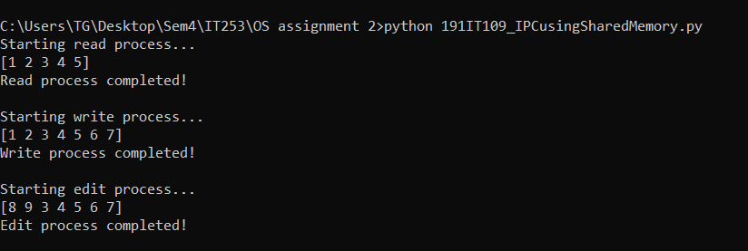Output Screenshot:

IPC has been implemented using multiprocessing library in python. To create shared memory space, multiprocessing.shared_memory.ShareMemory() has been used, and to create processes, multiprocessing.Process() is used. Finally, the shared space is initialized to a byte array [1,2,3,4,5] which is first read, then two more elements are added in write process and first two elements have been edited(overwritten) in the edit process.

THANK YOU